**Maven:-**

Requirement of framework for testing:

* We should not manage external jars(dependencies) Manually it should be manage by framework itself
* Once we shared the project to team or PM or stakeholders , then the project should be in executable format
* Detailed analysis tool should be available after execution (report)
* Can be executed through different ways
* **Maintains should be easy and framework should be stable for multiple versions of build**

**Maven Project:-**

Maven- It is build automation tool which compile and build the project according to dependencies version available in the **pom.xml** file and execute the complete project

Pom.xml:-

* It contains dependencies for building the maven project
* Supports build of maven project

Creation of Maven:-

Step 1:-

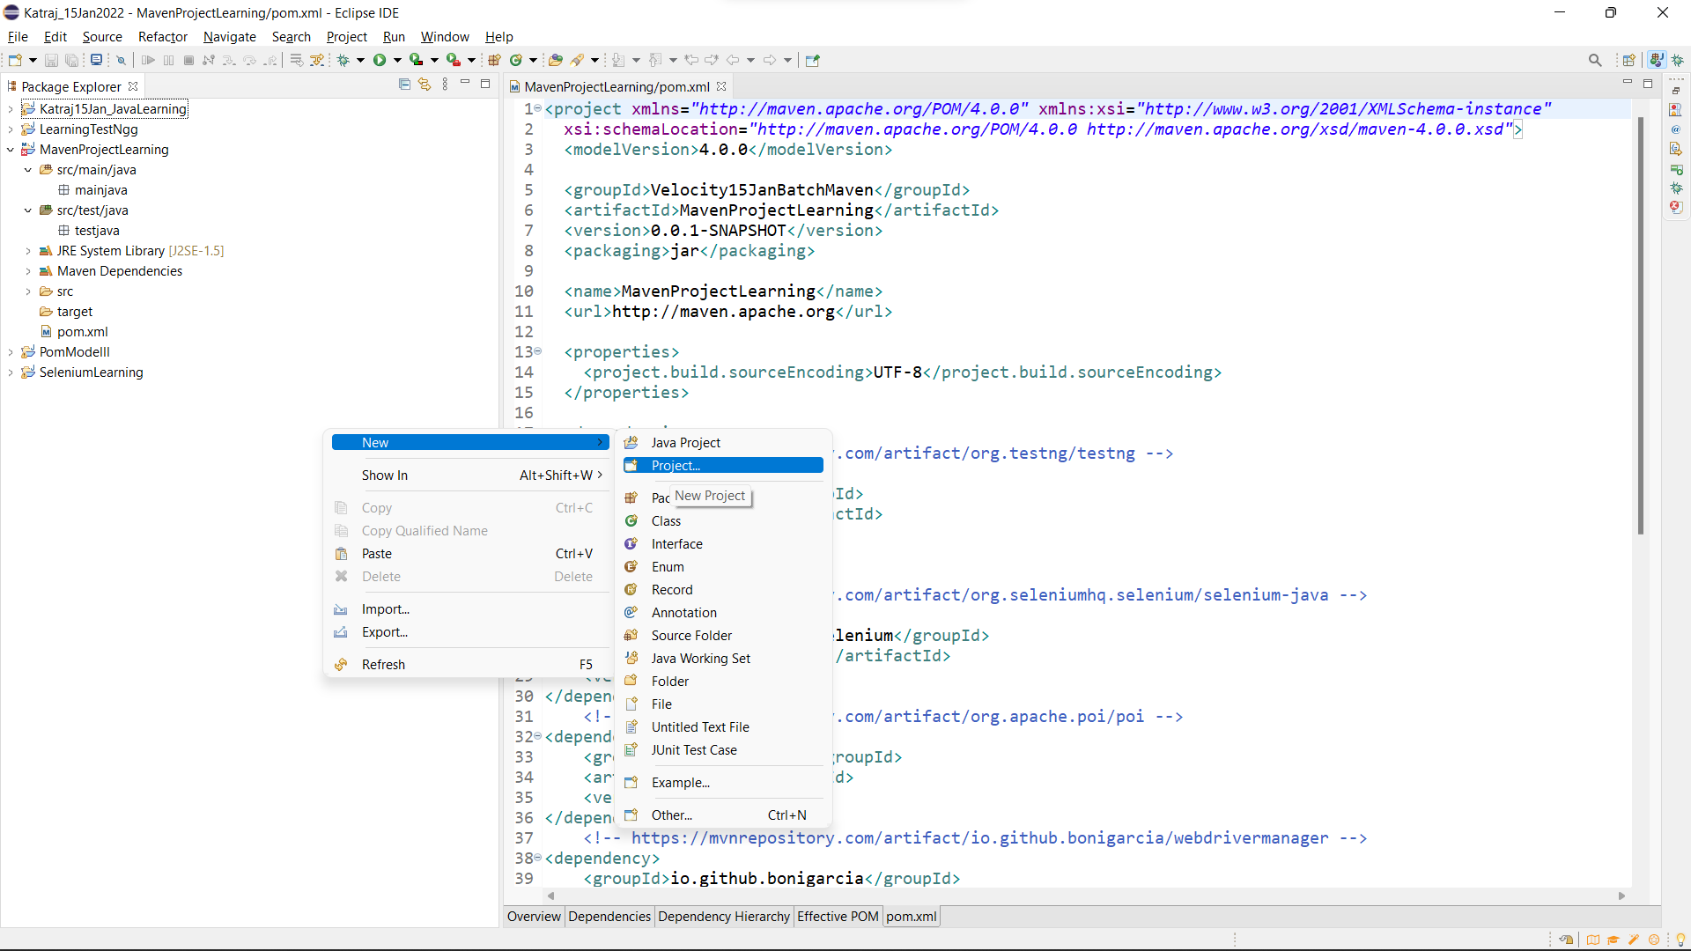

Select the project.

Step 2: Click on Maven and select Maven Project followed by click on the next button.

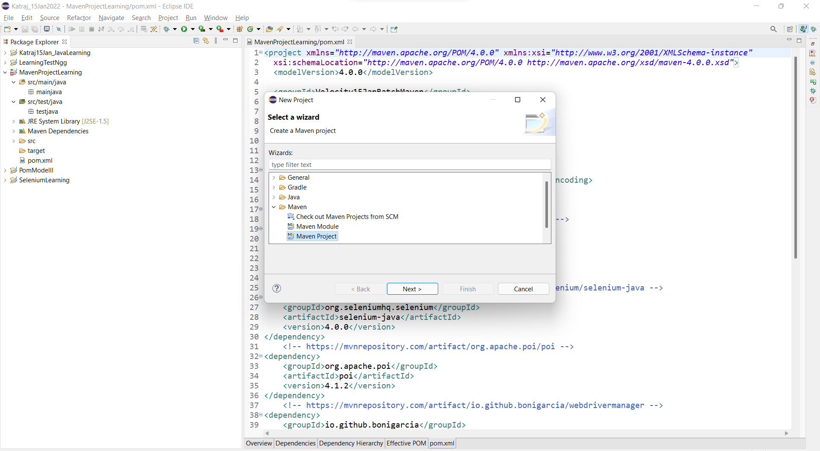

Click on Next and then again click on Next.

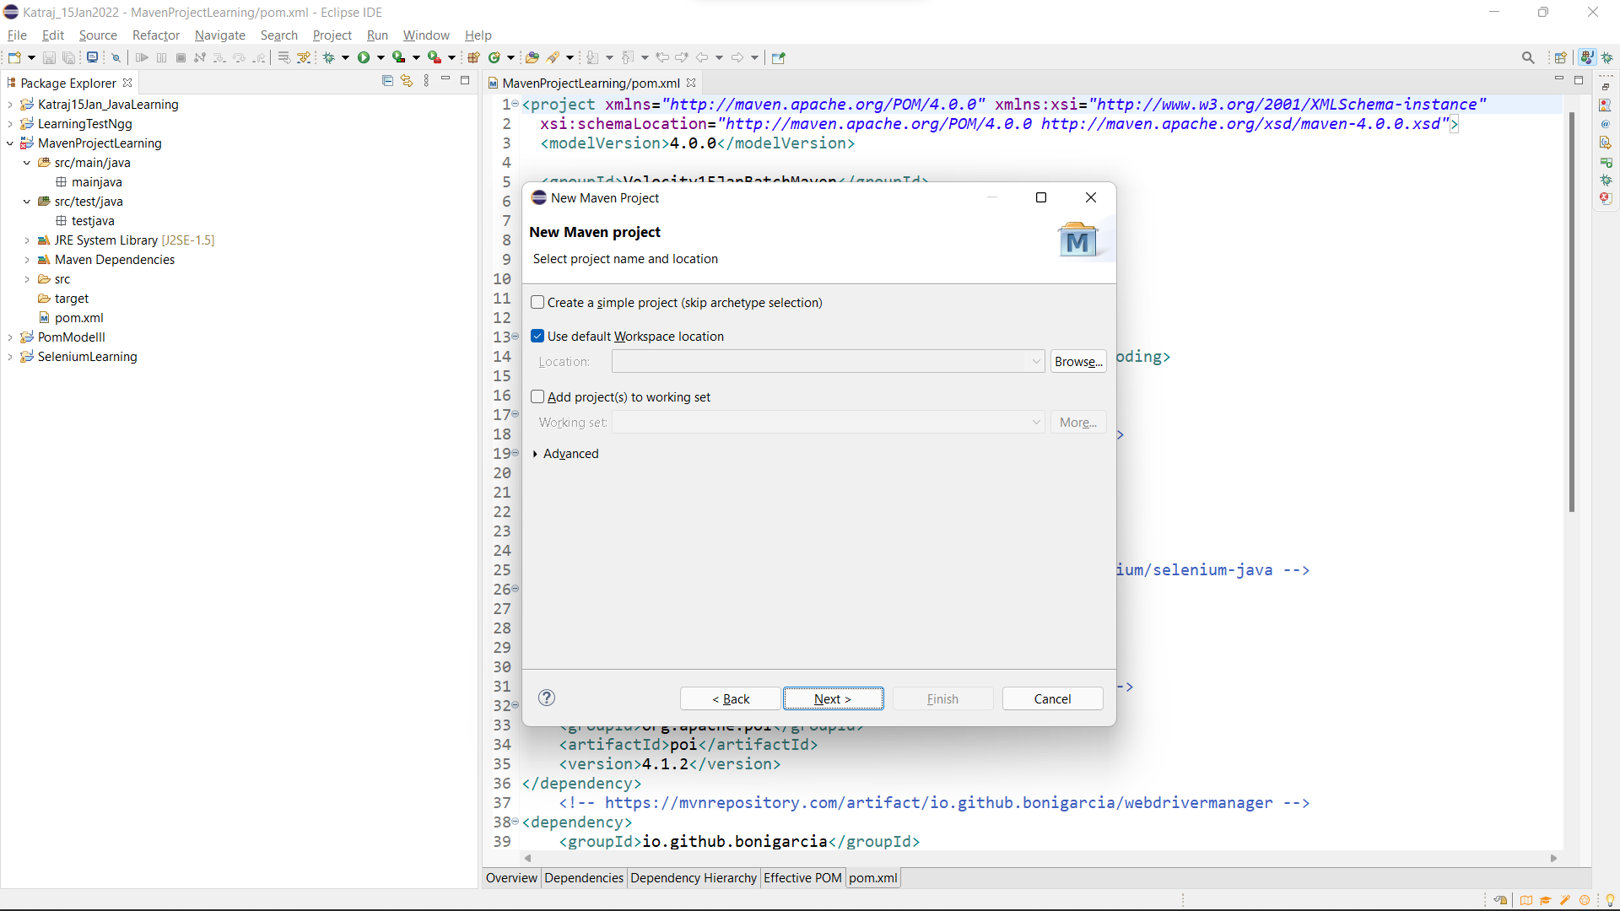

Step 3: Select the encircled type and click on the next button

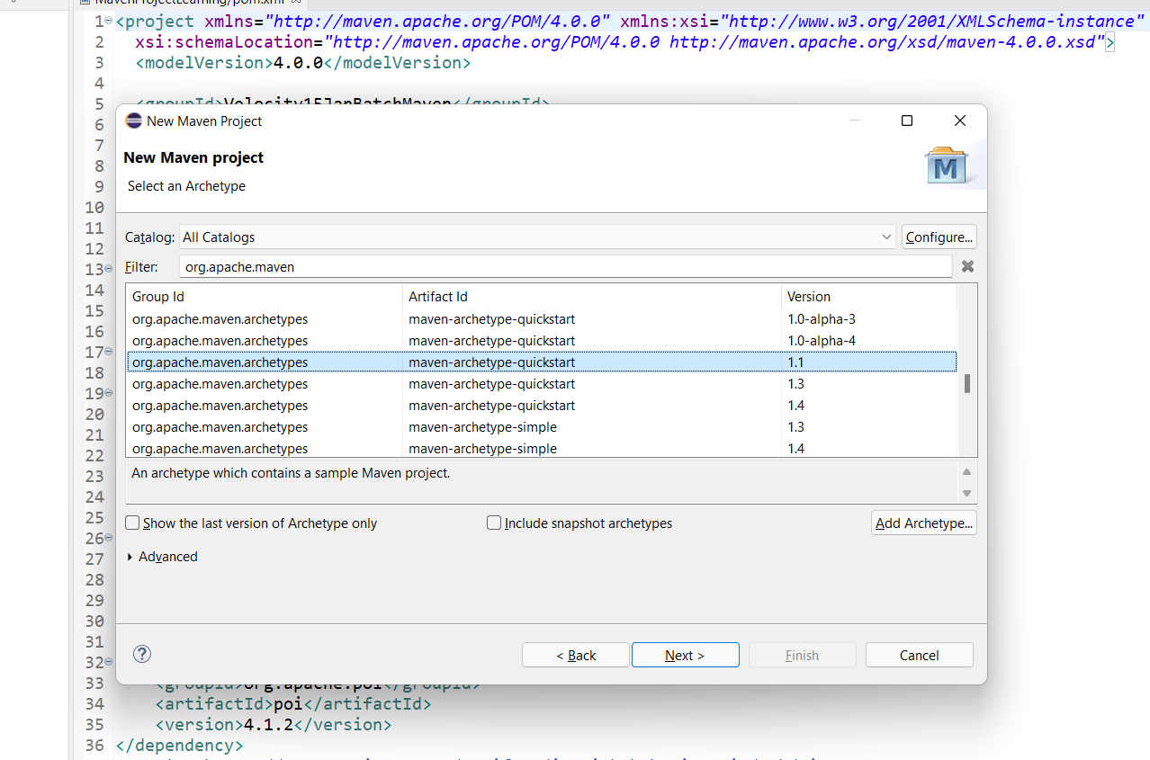

Step 4: Provide Artifact ID and groupId then click on Finish button.

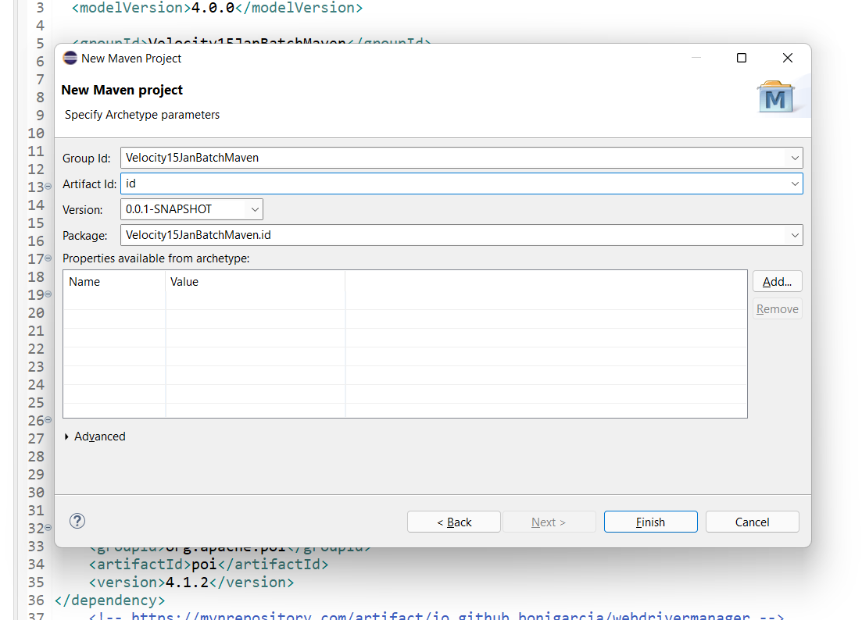

Step 5: Add all the dependencies followed by create packages inside src/main/java by the name of pages and create package testcases inside src/test/java.

Step 6: Write the code into them.

Step 7: To compile the code on java 8 we require **maven compiler** plugin and to configure our test execution we have to provide testng.xml file inside the pom.xml configuration by adding **maven surefire plugin.**

**To use maven compiler plugin copy the xml code from:**

[**https://maven.apache.org/plugins/maven-compiler-plugin/usage.html**](https://maven.apache.org/plugins/maven-compiler-plugin/usage.html)

**To use maven surefire plugin:**

[**https://maven.apache.org/surefire/maven-surefire-plugin/usage.html**](https://maven.apache.org/surefire/maven-surefire-plugin/usage.html)

Pom.xml:-

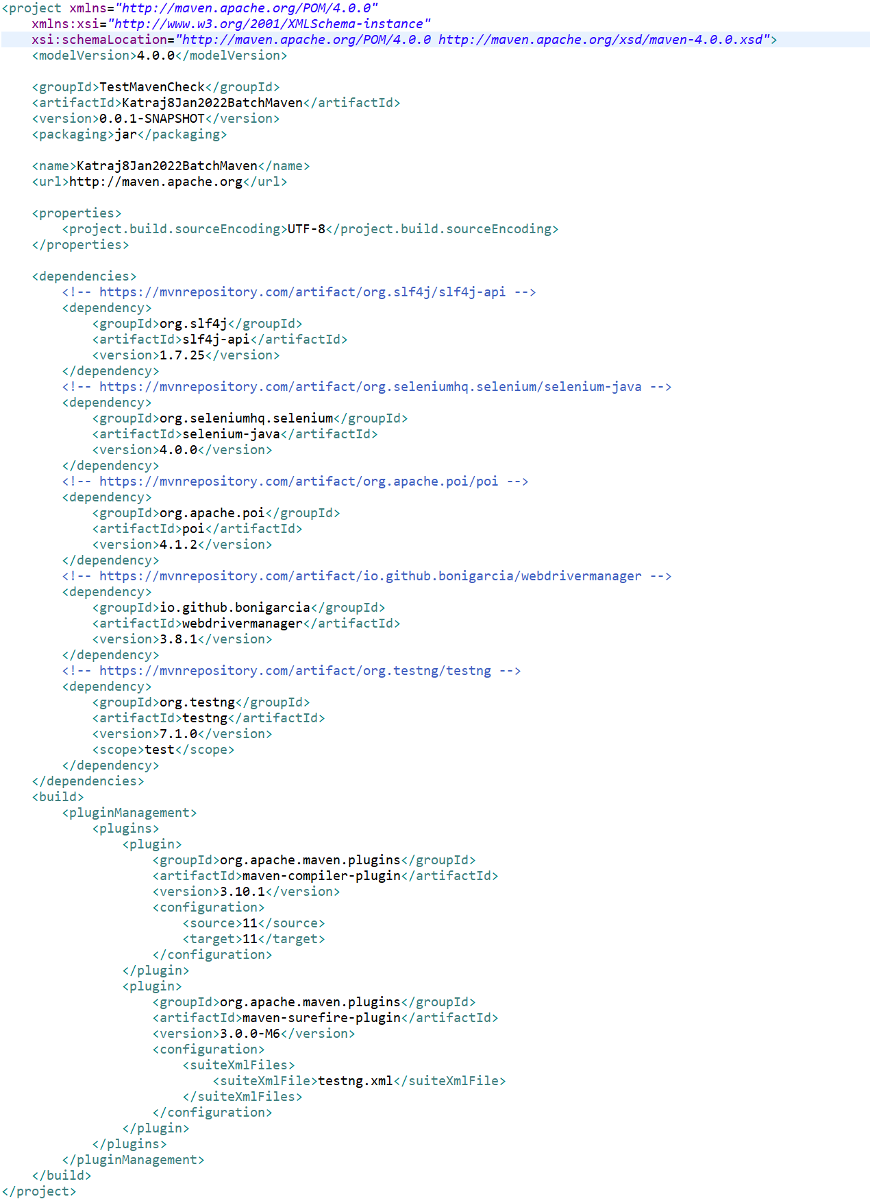

What is log4j?